Last Updated: 3/13/2024
This Quick Reference Guide (QRG) outlines the Executive Reviewer’s process to access Compensation Statements that detail merit award information.

Contents (Quick Links)
Accessing Statements via the Compensation Module 1
Accessing Individual Statements via Employee Central 2

Accessing Statements via the Compensation Module
Executive Reviewers may access bulk Compensation Statements and Individual Statements via the Compensation Module.
Via the OneCampus portal (one.purdue.edu), select Employee Launchpad

Log in using Purdue Career Account ID and BoilerKey.
Click the Home menu and then Compensation. | 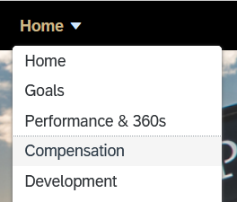
Choose Executive Review and select 20XX Merit Planning. | 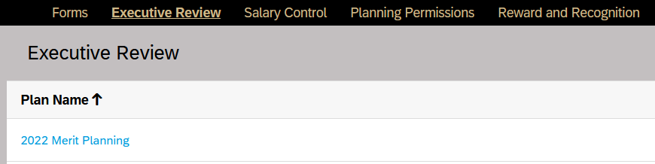
Use the Population icon to manipulate the data displayed as desired (e.g. display only specific compensation manger hierarchy) | 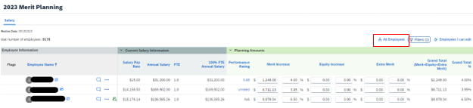
Team View (Second Manager) is synonymous with Compensation Managers in SuccessFactors. Team View with direct reports only selected displays employees for whom the selected user is the assigned compensation manager. Multiple levels selected displays those in the selected user’s compensation manger hierarchy for each level selected.  Select from the drop down Team View (Second Manager) then click on Find User.  Type in the first and last name of a Compensation Manager and click Search.  Select the Employee and hit Select at the bottom of the box.  Click on Select All or use the drop down to choose how many levels down you want to go to access comp statements. Click on OK. | 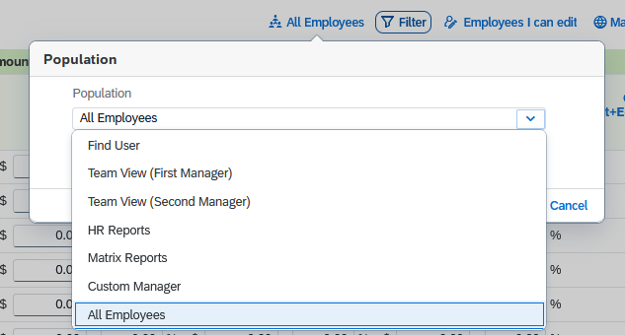  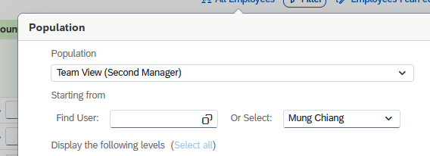  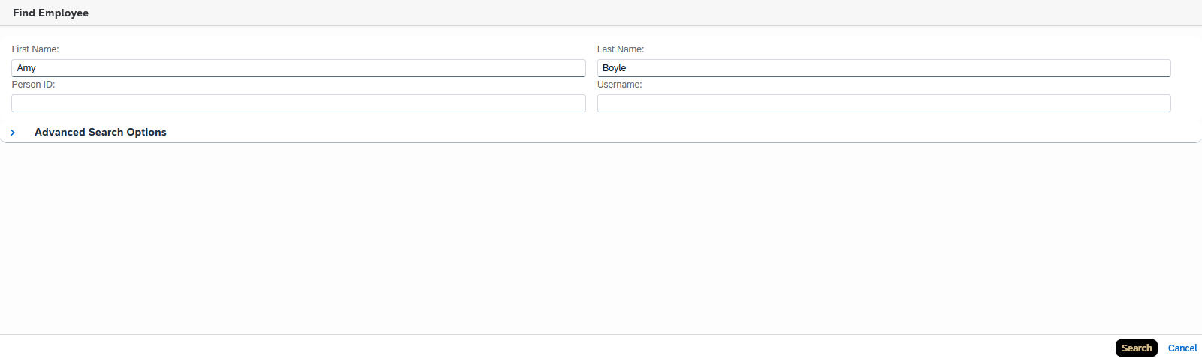  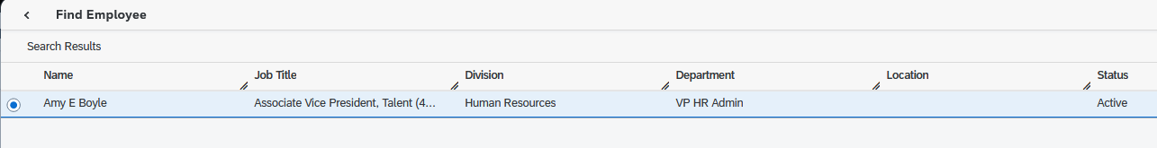  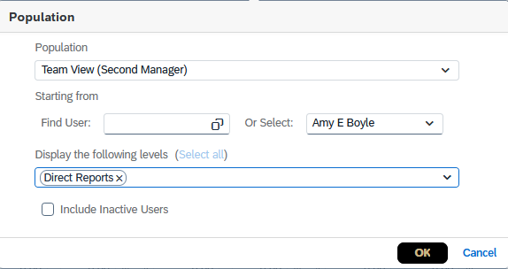
Click on the icon to Bulk Print Statement. | 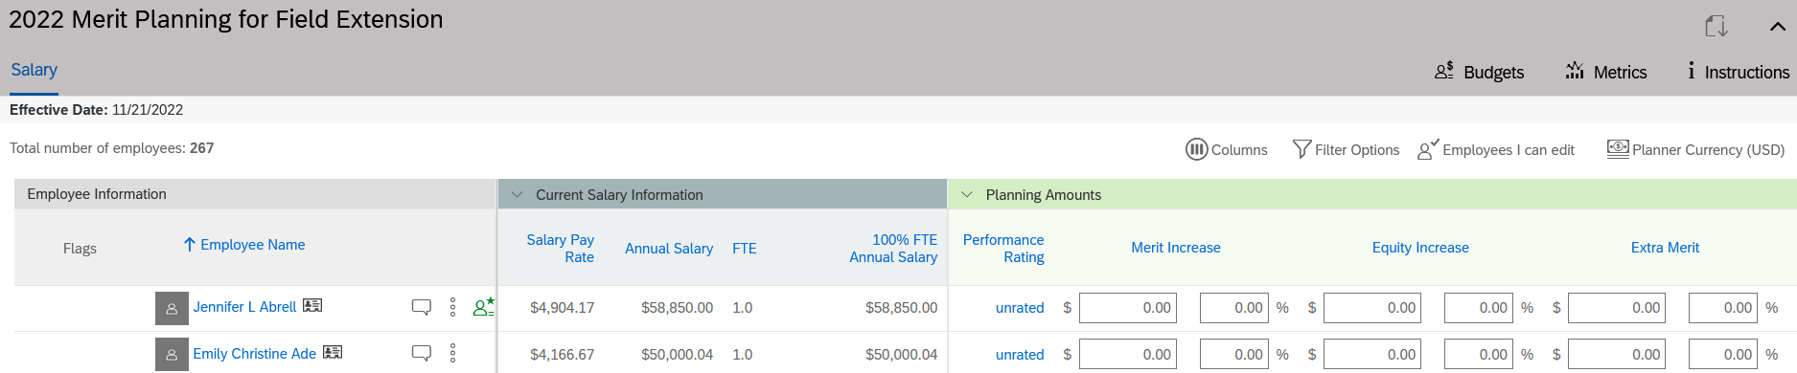
You will have the option to generate a separate PDF file for each employee (named by PERNR) or a single PDF file for all employees.  Select Continue. | 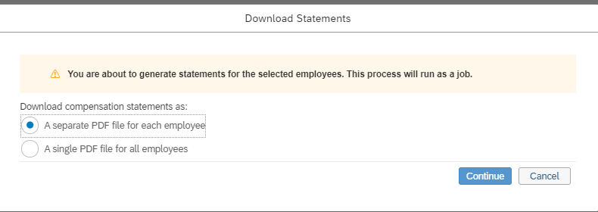
Download the Compensation Statements as a PDF in Scheduled Reports.  Click the Home menu and then Reporting. | 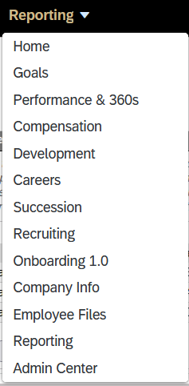
Ensure you choose  Select Scheduled Reports to download the zipped file. | 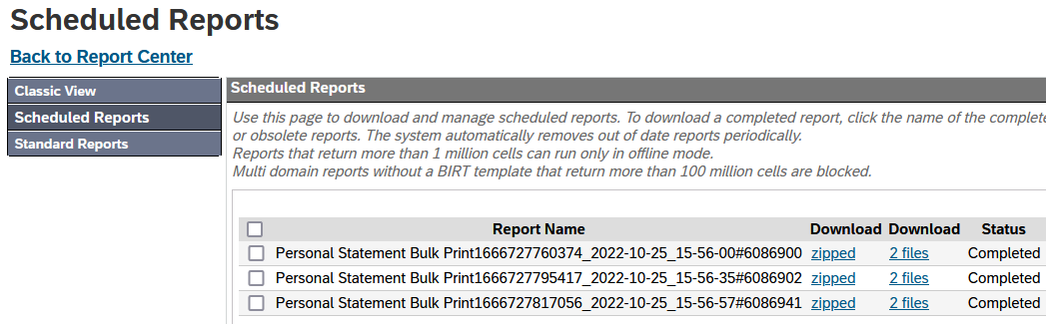

Accessing Individual Statements via Employee Central
Executive Reviewers may also access individual compensation statements via Employee Central.
Type an employee’s name in the search bar on the SuccessFactors Home Page and click on the name. | 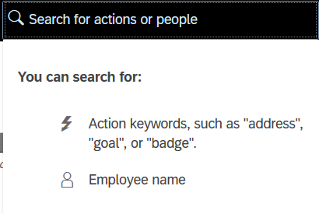
Choose Compensation Statement.
Click the 20XX Merit Planning hyperlink to view the current year’s statement in your browser.  Choose theicon to download a PDF version of the statement. | 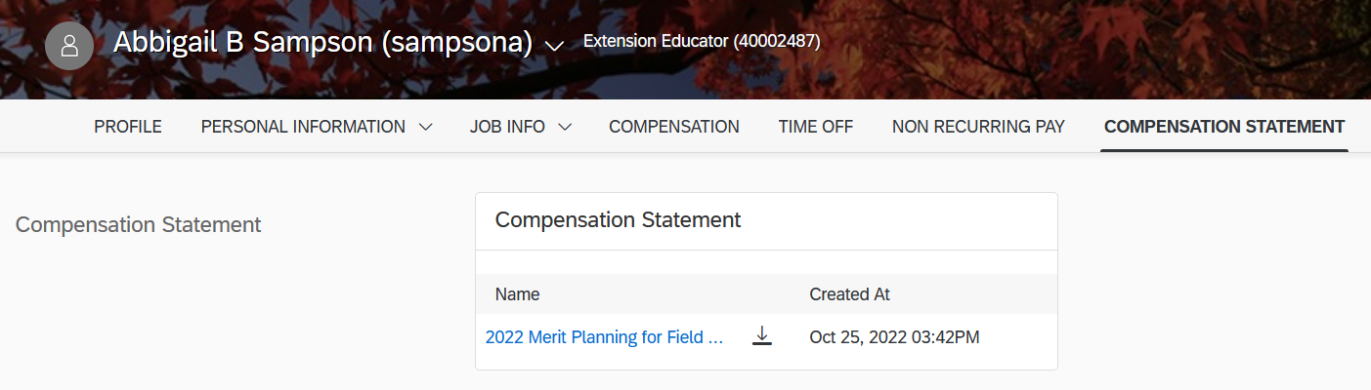
The statement will contain the Performance Rating for staff employees.  For hourly paid employees, it will show the current hourly base pay and annual base pay. For monthly paid employees, it will show the current annual base pay.  The Merit % Increase is the Grand Total %, which includes the Merit, Equity, and Extra Merit increase.  If an employee was promoted, the promotion $ increase and total % increase will be included.  For hourly paid employees, it will show the new hourly base pay and annual base pay. For monthly paid employees, it will show the new annual base pay.  If an employee receives a lump sum, it will be reflected on the statement as such. | 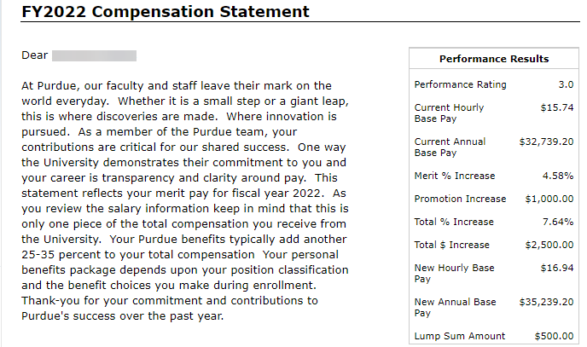
Note: Even if an employee has not received a merit increase, they will receive a Compensation Statement indicating no change in their salary. If you have any questions about the Compensation Statements, please contact your Compensation Analyst or compensation@purdue.edu.

